Tail dependence: GBPUSD and AUDUSD
Method 19 / daily log returns / alpha=0.05 / Alpari D1 full available history

Study setup
Logical pair: GBPUSD , AUDUSD
Broker symbols: GBPUSD_i , AUDUSD_i
Snapshot: 2026-11-03_majors_alpari_D1
Timeframe: D1
Matched return window: 1999-01-05 to 2026-11-02 (UTC bar dates)
Matched return count n: 7228
Dropped unfinished last bar dated 2026-11-03 UTC after a tick-volume check against the prior complete day.
Uniforms: ranks/(n+1); alpha=0.05
Complete matched rows (Excel): GBPUSD-AUDUSD_Tail_D1.xlsx
Complete matched rows (HTML table): GBPUSD-AUDUSD_Tail_D1_data.html

Method carried forward
Tail dependence counts how often both legs sit in an extreme uniform tail together. Matched daily log returns of close, ln(close_t / close_t-1), become u_i = rank(x_i)/(n+1) and v_i = rank(y_i)/(n+1). At alpha=0.05, lower L_hat = (# u<=alpha and v<=alpha) / (# conditioning leg <= alpha); upper uses >= 1-alpha. Both conditioning directions are reported with numerator and denominator counts. Quotes are not inverted. L_hat(0.05) is a finite-sample frequency, not the asymptotic lambda. Same-sample Pearson r is a side check. This is not causation and not a trading signal.

Results
tail | cond | L_hat | num | denom
lower | AUDUSD | 0.32964 | 119 | 361
lower | GBPUSD | 0.32964 | 119 | 361
upper | AUDUSD | 0.33795 | 122 | 361
upper | GBPUSD | 0.33795 | 122 | 361
Pearson r on returns: 0.539048

Conclusion
Over 7228 matched daily rows for GBPUSD and AUDUSD at alpha=0.05, lower L_hat conditioning on AUDUSD is 0.3296 (119/361); conditioning on GBPUSD is 0.3296. Upper L_hat conditioning on AUDUSD is 0.3380; on GBPUSD is 0.3380. Pearson r = 0.5390. These are finite-sample frequencies, not asymptotic lambda and not a trading signal.

Charts
Daily closes

Daily log returns

Uniforms with alpha lines
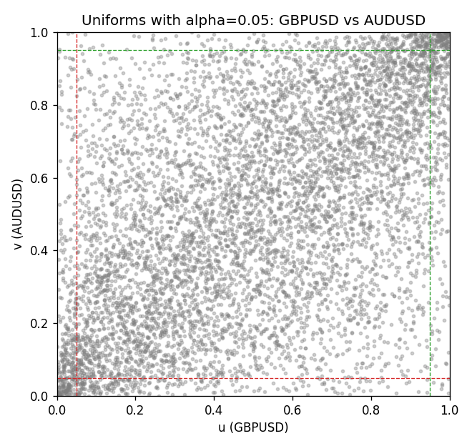

Data report
Every matched row is stored in the sibling Excel workbook named GBPUSD-AUDUSD_Tail_D1.xlsx, including u and v. Embedding all rows as a Word table is impractical; this file holds column summaries and the first and last 15 matched rows.
Columns: time, GBPUSD_open, AUDUSD_open, GBPUSD_high, AUDUSD_high, GBPUSD_low, AUDUSD_low, GBPUSD_close, AUDUSD_close, GBPUSD_tick_volume, AUDUSD_tick_volume, GBPUSD_spread, AUDUSD_spread, GBPUSD_real_volume, AUDUSD_real_volume, GBPUSD_log_return, AUDUSD_log_return, u, v
Column summaries (matched calculation rows)
column | count | mean | std | min | 25% | 50% | 75% | max
GBPUSD_open | 7228 | 1.5166822 | 0.21834818 | 1.06854 | 1.3254025 | 1.51196 | 1.63237 | 2.1066
AUDUSD_open | 7228 | 0.75192541 | 0.13534725 | 0.4785 | 0.66102 | 0.7315 | 0.8091975 | 1.10284
GBPUSD_high | 7228 | 1.5229801 | 0.21891417 | 1.08366 | 1.3300275 | 1.518725 | 1.638825 | 2.1161
AUDUSD_high | 7228 | 0.75597511 | 0.13590934 | 0.4878 | 0.664695 | 0.734945 | 0.81552 | 1.10795
GBPUSD_low | 7228 | 1.5103473 | 0.21757706 | 1.03518 | 1.32009 | 1.50469 | 1.624985 | 2.0983
AUDUSD_low | 7228 | 0.74786335 | 0.13465689 | 0.4775 | 0.6577 | 0.72762 | 0.804475 | 1.0975
GBPUSD_close | 7228 | 1.5167386 | 0.2183035 | 1.06879 | 1.32568 | 1.51203 | 1.6324775 | 2.1065
AUDUSD_close | 7228 | 0.75196864 | 0.13532707 | 0.4786 | 0.6611875 | 0.731775 | 0.809315 | 1.10169
GBPUSD_tick_volume | 7228 | 94565.268 | 153330.81 | 62 | 9974.5 | 52775.5 | 91622.5 | 1273370
AUDUSD_tick_volume | 7228 | 77126.179 | 137934.11 | 109 | 5406 | 43250.5 | 71246.75 | 1234623
GBPUSD_spread | 7228 | 27.003182 | 19.183813 | 0 | 11 | 20 | 50 | 50
AUDUSD_spread | 7228 | 30.855562 | 16.875394 | 0 | 13 | 30 | 50 | 50
GBPUSD_real_volume | 7228 | 3.5428062e+09 | 8.4280615e+10 | 0 | 0 | 0 | 0 | 2.4038164e+12
AUDUSD_real_volume | 7228 | 5.2225089e+09 | 1.2514647e+11 | 0 | 0 | 0 | 0 | 3.811512e+12
GBPUSD_log_return | 7228 | -2.954e-05 | 0.0056473 | -0.08388241 | -0.00313242 | 3.002e-05 | 0.00317333 | 0.03112653
AUDUSD_log_return | 7228 | 1.629e-05 | 0.00754363 | -0.08602525 | -0.00386494 | 0.00027649 | 0.00415111 | 0.0806166
u | 7228 | 0.5 | 0.28865516 | 0.00013833 | 0.25006917 | 0.5 | 0.74993083 | 0.99986167
v | 7228 | 0.5 | 0.28865515 | 0.00013833 | 0.25006917 | 0.5 | 0.74993083 | 0.99986167
First 15 matched rows (selected columns)
time | GBPUSD_log_return | AUDUSD_log_return | u | v
1999-01-05 | -0.0028966287 | -0.00080418179 | 0.26642689 | 0.4317333
1999-01-06 | -0.00060452184 | 0.011836351 | 0.44238484 | 0.95863882
1999-01-07 | -0.002118709 | 0.0088650256 | 0.32120625 | 0.91700097
1999-01-08 | -0.0058954193 | 0.00031515916 | 0.11813529 | 0.5028358
1999-01-11 | -0.0056851331 | 0.0072213815 | 0.12505187 | 0.87771476
1999-01-12 | 0.0022657001 | -0.0048608485 | 0.68916863 | 0.2058376
1999-01-13 | 0.0091330396 | -0.0078902098 | 0.95476553 | 0.11149537
1999-01-14 | 0.0019376331 | -0.002696916 | 0.66219394 | 0.31249135
1999-01-15 | -0.0017558204 | 0.007123101 | 0.34873426 | 0.87370314
1999-01-18 | 0.0012112405 | 0.00094592471 | 0.60423295 | 0.54724028
1999-01-19 | 0.0018745281 | 0.0072225153 | 0.65638401 | 0.87785309
1999-01-20 | -0.0049053846 | 0.0012507819 | 0.15659151 | 0.56729838
1999-01-21 | 0.0031518998 | 0.00078094498 | 0.74823627 | 0.53603541
1999-01-22 | 0.0024781662 | -0.012252745 | 0.70438512 | 0.044127819
1999-01-25 | 0.0012066366 | -0.0039591468 | 0.60381796 | 0.24526214
Last 15 matched rows (selected columns)
time | GBPUSD_log_return | AUDUSD_log_return | u | v
2026-10-13 | 0.0036434319 | 0.0035007712 | 0.77770093 | 0.71282335
2026-10-14 | -0.0049164679 | -0.0015193215 | 0.15603818 | 0.3829022
2026-10-15 | 0.0065976411 | -0.0075447063 | 0.90358279 | 0.11813529
2026-10-16 | 0.0037592051 | 0.0033906408 | 0.78447918 | 0.70701342
2026-10-19 | -0.0017500314 | 0.0050859986 | 0.34984092 | 0.79526906
2026-10-20 | 0.0055923442 | 0.0034620426 | 0.87052151 | 0.71074837
2026-10-21 | 0.0012476328 | 0.0036066384 | 0.60699959 | 0.7196016
2026-10-22 | 0.00022396082 | -0.0012672558 | 0.51860562 | 0.40074699
2026-10-23 | -0.0021146949 | 0.0023765656 | 0.32175958 | 0.63867755
2026-10-26 | -0.0024340661 | -0.0032032829 | 0.29727487 | 0.28358002
2026-10-27 | -0.0023648393 | 0.0016669876 | 0.30239314 | 0.59164476
2026-10-28 | 0.0015771808 | 0.0040915541 | 0.63383594 | 0.74699129
2026-10-29 | 0.0035881935 | -0.0040915541 | 0.77548762 | 0.23972887
2026-10-30 | 0.0013450605 | 0.0010102376 | 0.61488449 | 0.55042191
2026-11-02 | 0.0010971256 | -0.0049184984 | 0.59482639 | 0.2032093

